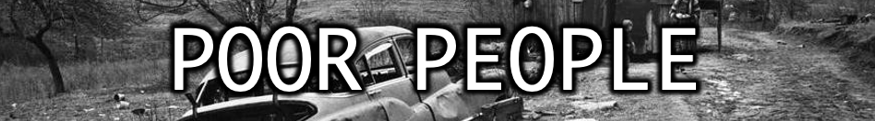
OCTOBER 9, 2022

Source text: James 2:1-9; 2 Cor. 8:9

What comes to mind when we hear the phrase “poor people”?

James warns us not to show ______________________. (Js. 2:1)
When we do we become ______________ with __________ thought. (Js. 2:4)
God has chosen the __________ in the world to be _________ in faith and __________ of the _____________. (Js.

In Luke 14 we are encouraged to do good unto the ________, the __________, the ________, and the ________. (vs. 13)

Why does it way we will be blessed in this? ______________________________________________

Jesus said the poor widow in Luke 21 gave more ______ _____ ____ ________.

We are told in 2 Corinthians 8:9 why Jesus became poor.

By His poverty we _______ __________ ______.

Therefore, we should have the same attitude Paul professes in 1 Cor. 2:2 & Philippians 3!

As a child of God one of our greatest treasures is the ________ ______ ______ _________. (Eph. 1:7)

Closing Thought:
What do real riches look like?
In him we have redemption through his blood, the forgiveness of our trespasses, according to the riches of his grace, which he lavished upon us, in all wisdom and insight making known to us the mystery of his will, according to his purpose, which he set forth in Christ as a plan for the fullness of time, to unite all things in him, things in heaven and things on earth. -Ephesians 1:7-10

